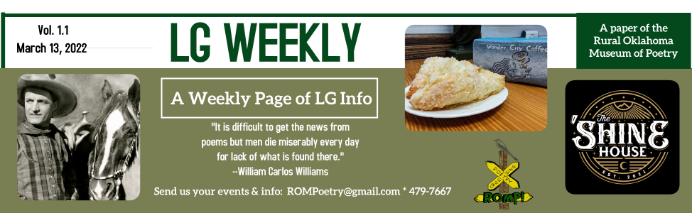

LG WEEKLY is a new one-page publication that will offer any news that we can find or are given of things going on in Locust Grove, Oklahoma. We need you to send us your events, sales, specials, and more. We want to be an easy-access resource for people to keep them informed on all things LG. Email us at ROMPoetry@gmail.com or call 918-479-7667. Phone is answered when museum is open, Thu.-Sat. 10-5. You can also drop information by the museum or mail us at PO Box 1243 LG OK 74352. We are at the corner of Delaware & Main.
From the editor: I hate posting flyers. I know they work and they are often the only way to get information out to people, especially if you have an aversion to Facebook or its algorithms simply never showing you anything worthwhile. But I hate posting flyers. That said, this paper is partly a result of the fact that . . . I hate posting flyers. If you do, too, let us help you help people in LG know about what’s going on with your business or organization. Do you have events coming up? A special sale? Just something cool you want people to know about? Email me. I write a weekly column for The Paper, the only newspaper left in Mayes County, and it’s a paper, so not widely read because the majority of people don’t read papers anymore, and, in fact, if you have read this far, you are sort of reading a paper, so that’s cool. Thanks. –Shaun Perkins

TOWN MEETING March 14
If you truly want to know what’s going on with town business and have questions, comments or concerns, attend a town council meeting. It’s at 6:30 p.m.
OKIE ANIMAL CELEBRATION Mar. 19
Join the Rural Oklahoma Museum of Poetry in celebrating the exhibit Where They Went: A Photographic History of Oklahoma Animals on display at ROMP March 3-April 30.

This exhibit features photos curated from the Oklahoma Historical Society’s archives. The images express the friendly relationship between humans and their domestic and farm animals throughout Oklahoma’s history.

To celebrate, ROMP will have fun activities, including professional photographs with your pet(s), animal contests, a food truck (free food from Neighbor’s Fork) and decorate a stuffed dog contest.

The Animal Contests will be
--Most unusual pet
--Owner and pet look-a-like
--Best dressed pet
--Most talented pet
Winners will receive gift certificates to area businesses.
LG WEEKLY is available every Monday at these locations: Rowland’s Quick Shop, ROMP, Wonder City Coffee, ROMP Rummage and Low Water Dam Store. The deadline to give us news is Saturday at noon each week.

Schedule:
10:00: Museum opens, visit exhibit
11:00-2:00: Photographs taken
11:00-2:00: Food truck open
Noon: Pet Contest Judging
2:00: Decorated stuff dog contest entries due

ALL SCHOOL REUNION

--Hugh J. Callery
hcallery@hotmail.com

NOTE: An LG All-School Reunion will probably take place on Founder’s Day, but Hugh J. needs some help planning. Read on!

In the past, there has never been a formal committee of people who put the reunion together. Joan Bennett had several people who assisted her. Before Joan, it was Rosemary and Kelsey Holman who ran the reunion. Before them, I think it was Joan’s mother, Maxine.

Our reunion needs some new blood. It needs a few people of all ages to take a serious look at the event and make whatever changes it may need to accommodate today’s environment. We were in the process of making some changes but were unable to implement all of them because the Covid virus cancelled the past two reunions.

I’d like to schedule an open meeting to discuss the annual school reunion. If you are interested, let me know in the comments section of this post, message me on Facebook or e-mail me and I’ll set a date for us to get together.
THIS WEEK:

Monday, Mar. 14
- 6:30 p.m. Town Council Meeting
- 6:30 p.m. LG Public Schools Board Meeting

Tuesday, Mar. 15
- 9:30-11:30, LG Food Pantry (479-6356)
- 3-4p.m. Tai Chi & Poetry for Older Adults (ROMPoetry.com)
- 6:30 p.m. LG Police: Camera Discussion, Town Hall

Thursday, Mar. 17
- 11 a.m. LG Library Storytime
- 6 p.m. LG Chamber meeting, Town Hall
- 6:30-8 p.m. Let’s Talk About It book club (ROMPoetry.com)
- Shine House, extended hours, 4-1:30 a.m.

Friday, March 18
- New episode of Wacky Poem Life podcast out (WackyPoemLife.com)
- Shine House, music by Blane Hewitt 9-12:30 a.m.

Saturday, Mar. 19
- 10-3, Okie Animal Celebration. See ROMPoetry.com.

All Week, Mar. 14-19
- ROMP Rummage Bag Sale on Clothes: $2 a bag, 112 E. Main
- Spring Break for Public Schools

LG Police Discussion Mar. 15

The LG PD invites the community to an information conference regarding the license plate readers that have been set up in town. 6:30 p.m. at town hall.

Madelyn’s Needs Vases

Bring any extra vases you have to Madelyn’s Flowers, and they will donate $1 for each to Safenet, a Mayes County nonprofit helping with domestic abuse issues.
WONDER CITY COFFEE
St. Patrick’s Day Drink Specials:

Treat yourself to an Irish drink this week. Here are three that WCC is offering:
- Seamair Og is a mocha and peppermint frappe.
- The Pot of Gold, is a hazelnut and Irish cream latte (hot or iced).
- Leprechaun Lemonade is a refreshing Raspberry Lemonade to put a spring in your step!

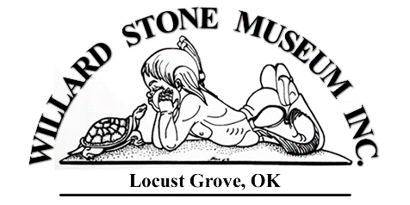

The WSM board of directors is continually working on fundraising and grant-writing projects to make the new museum a reality. The first bank building in town at Ross & Broadway is now owned by the WSM, but funds continue to be needed to start renovation of the building.

For more information, see WillardStoneMuseumInc.com where there are pictures of the proposed renovations that would make this corner of LG a really stunning place.

Donate if you can at the website or send checks to WSM, PO Box 833, LG OK 74352.

LGHS ART TEACHER

Liz Boney, new art teacher at LGHS, is doing great things with her students. Check out the recent stop-motion videos her students produced on this Facebook page: Ms Boney’s Class.

You can also search for her class on DonorsChoose.org and make a donation to fund her future classroom projects.



THE SHINE HOUSE
St. Patrick’s Day Specials

In honor of St. Patrick’s Day, the Shine House will be open extended hours that day, 4:00 p.m. to 1:30 a.m. with these specials:
- $3 Shamrock shots
- $5 Fuzzy Leprechauns
- $5 Irish Car Bombs

On March 18, Blane Hewitt will be back by popular demand to sing some country tunes from 9:00 p.m.-12:30 a.m.

Spring Fling CRAFT SHOW

The LG Chamber is hosting a craft show on April 1 & 2, at the VFW Hall. Indoor and outdoor vendor space is available at varying rates. Vendor forms can be found at LocustGroveOklahoma.com or picked up at ROMP.

LOCAL PETAL Spring Fling

The Local Petal is having a Spring Fling Arrangement Class on Fri. March 25, 5-7 p.m. There will be step-by-step instructions with some spring flowers, plus snacks and drinks. Call, text or use Facebook to reserve a spot. 539-210-5141.

STORYTELLING

LG is lucky to be home to some great storytellers, such as Choogie Kingfisher, Wendell Wolf and Wayne Holman. Wayne was the star opener at the recent Okie Animals Story Hour at Wonder City Coffee. He started telling stories out on the sidewalk and kept going as we went inside.

Tell stories to your children. Tell them to your grandchildren. Read to them but also tell stories from your face. The world needs more of this kind of interaction.

Decorate this stuffed dog with poetry and designs at the Okie Animal Celebration Mar. 19. See details on other side. Great prizes for winners!
←

